Requirements Specification Document

INTRODUCTION
Purpose of the document
The purpose of this document is to define the functional and non-functional requirements for "The Brew Cave Management System." It serves as a guide for the development team to ensure the software meets the operational needs of the client.

Overview of the software system
The system is a Web-Based Point-of-Sales (POS) and Inventory Management System designed specifically for a coffee shop and diner environment. Its core differentiator is the "Recipe Costing Logic," which automates inventory deduction based on the ingredients used per menu item (e.g., 1 Latte = 18g Beans + 200ml Milk).

Scope
The system includes three main modules:
- Admin Dashboard For sales analytics, user management, and remote monitoring.
- POS Interface A tablet-optimized ordering system for cashiers.
- Inventory System A backend module for stock tracking and recipe configuration.

Functional Requirements
ID | Requirement Description | Priority | Dependencies | Acceptance Criteria
FR-01 | Authentication: The system shall allow users (Admin/Cashier) to log in using a username and password via a split-screen interface. | High | None | User is redirected to the appropriate dashboard upon valid credentials.
FR-02 | POS Ordering: The system shall display menu items in a grid layout with category filters (e.g., Coffee, Pasta) and allow the Cashier to add items to a cart. | High | FR-01 | Selected items appear in the checkout panel with correct pricing.
FR-03 | Recipe Deduction: The system shall automatically deduct raw ingredients from the inventory database immediately upon checkout confirmation | High | FR-02 | Stock levels for milk/beans decrease by the exact recipe amount after a sale.
FR-04 | Inventory Management: The system shall allow the admin to "Add," "Drop," or "Delete" stock items manually to account for deliveries or spoilage. | Medium | FR-01 | Inventory counts are updated and logged in the database.
FR-05 | Low Stock Alert: The system shall display a warning on the Dashboard when an ingredient's quantity falls below the reorder level (Par-Stock). | Medium | FR-04 | Alert appears in the "Overview" widget when the threshold is reached.
FR-06 | Sales Reporting: The system shall generate visual analytics (graphs/charts) for Daily, Weekly, and Monthly sales performance. | Medium | FR-02 | Admin can view accurate total sales and best-selling items remotely.
FR-07 | Sales Reporting: The system shall generate visual analytics (graphs/charts) for Daily, Weekly, and Monthly sales performance. | Low | FR-01 | New staff accounts can successfully log in with restricted access.

Non-Functional Requirements
Performance
The POS interface must load menu items within 2 seconds on a tablet device to ensure fast service during peak hours (7pm-10pm).
Usability
The interface shall feature large, touch-friendly buttons and a minimalist design to reduce the learning curve for non-technical staff.
Reliability
The system must implement data persistence to ensure no transaction data is lost during a power outage; operations must continue on battery power for 2-4 hours.
Security
Passwords must be hashed (encrypted) in the database. The system shall auto-logout users after a defined period of inactivity.
Scalability
The architecture must be cloud-native (hosted online) to allow for remote access by the owners from home.
Maintainability
The code shall follow a 3-Tier Architecture (Frontend, Backend, Database) to allow for easy updates to the Recipe Logic without breaking the POS view.

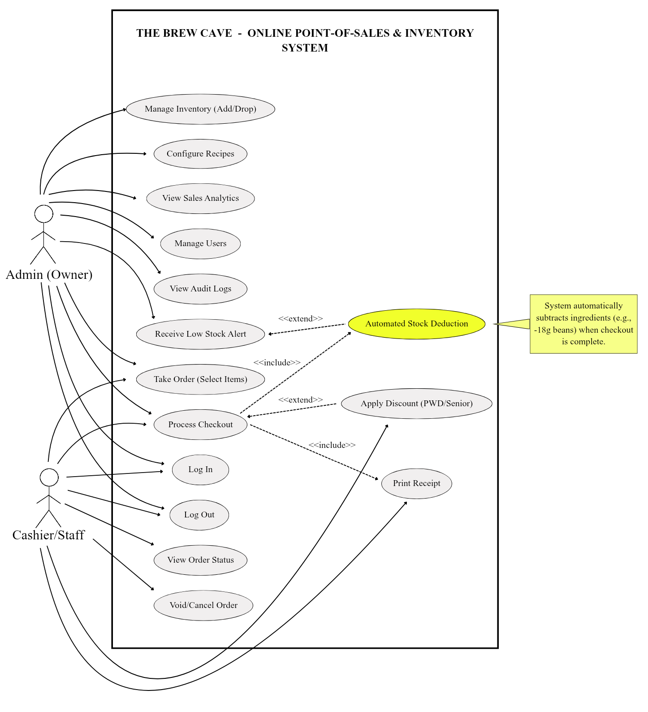
Use Cases

Data Requirements

Data Entities:
Users: (ID, Username, Password, Role).
Products: (ID, Name, Category, Price, Image).
Ingredients: (ID, Name, Quantity, Unit, Reorder_Level).
Recipes: (Product_ID, Ingredient_ID, Amount_Required).
Transactions: (ID, Date, Total_Amount, Staff_ID).

Attributes: Prices are decimal; Quantities are integers/decimals; Usernames are unique strings.

Relationships:
One Product has many Ingredients (via Recipe).
One Transaction contains many Products.

Use Case Explanation:
Overview
The diagram illustrates the functional requirements of the system by depicting the interactions between the primary users (Actors) and the system’s modules (Use Cases). The system boundary represents the "Online Point-of-Sales & Inventory System."
The Actors
The system features two distinct user roles with different access levels:
- Admin (Owner): The super-user who has unrestricted access to all system functionalities. They are responsible for backend management (Inventory, Users, Reports) and can also perform frontend tasks.
- Cashier/Staff: A restricted user whose role is limited to operational tasks such as processing orders, handling payments, and viewing order status.
Functional Modules (The Ellipses)
- Authentication: Both actors must Log In to access the system and Log Out to secure the session.
- Point of Sale (POS) Operations:
  - Take Order (Select Items): The core function where the cashier selects products.
  - Process Checkout: The final step of the transaction loop.
  - Void/Cancel Order: Allows staff to cancel a transaction if a customer changes their mind.
  - View Order Status: Likely used for the "Kitchen View" to see pending orders.

- Admin-Only Management:
  - Manage Inventory (Add/Drop): Adjusting stock levels manually.
  - Configure Recipes: Linking menu items to ingredients (The core "Recipe Logic").
  - View Sales Analytics: Monitoring business performance.
  - Manage Users: Creating accounts for staff.
  - View Audit Logs: Tracking system activities for security.
Advanced System Logic (Relationships)
This is the most critical part to explain to your panel, as it shows the system's "intelligence."
- The <<include>> Relationship (Mandatory Action):
  - Automated Stock Deduction: When Process Checkout occurs, the system automatically triggers the "Automated Stock Deduction" use case. This signifies that inventory updates happen instantly and cannot be skipped.
  - Print Receipt: Every checkout includes the generation of a receipt.
- The <<extend>> Relationship (Optional Action):
  - Apply Discount: This extends Process Checkout. It is optional because not every customer is a PWD or Senior Citizen.
  - Receive Low Stock Alert: This extends Automated Stock Deduction. The alert is only triggered if the stock level falls below the critical threshold during the deduction process.

Assumptions and Constraints
Assumptions:
- The client will provide the necessary hardware (Laptop and Tablet).
- A stable Internet connection (Fiber or Mobile Data) is available for cloud synchronization.
Constraints:
- Budget: The project relies on Open-Source tools to keep costs minimal (approx. ₱3,000 - ₱5,500 for hosting).
- Timeline: The Critical Path (Recipe Logic) must be completed by February 2026 to ensure on-time delivery.
Glossary
POS (Point of Sale)
The interface used by the cashier to process transactions.
Par-Stock
The minimum level of inventory required before a reorder is necessary.
Recipe Costing
An algorithm that calculates inventory usage based on the specific ingredients defined for a menu item.
UAT (User Acceptance Testing)
A phase where the client tests the system in a live environment.

